THE GRADUATE SCHOOL

PHD IN CREATIVE PRACTICE
GUIDELINES

Eurosatory Arms Fair, Paris
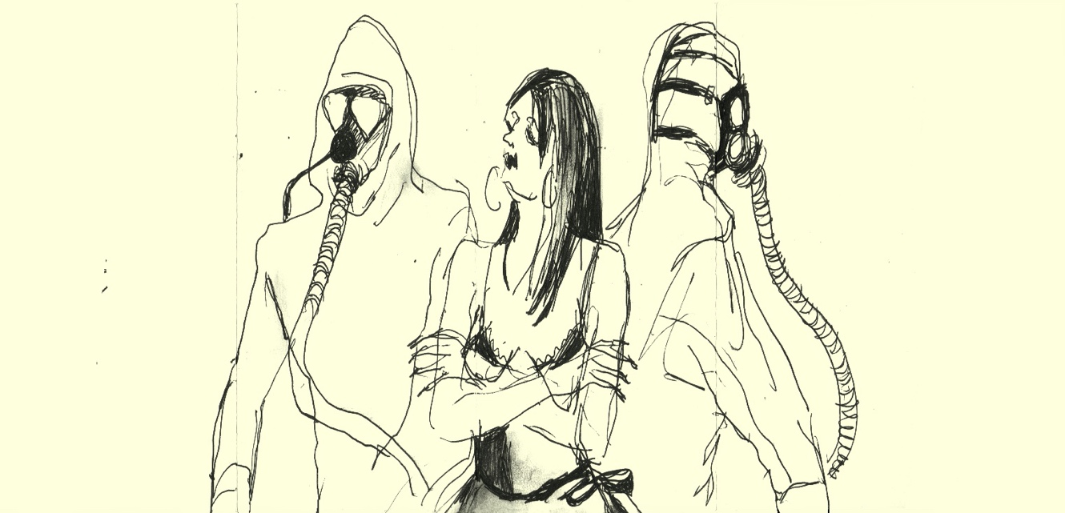
Dr Jill Gibbon, Leeds School of Arts

PHD IN CREATIVE PRACTICE

INTRODUCTION
These guidelines provide information for the award of PhD in Creative Practice in conjunction with the Academic Regulations, Section 11: Research Awards and the Research Student Handbook. The University offers this route to candidates who intend to produce creative research outputs by practice and are seeking through this award to demonstrate originality, reach and significance within their discipline.
OVERVIEW
The PhD in Creative Practice submission will include:
- A substantial body of creative work that is well documented (Practical).

with

- A contextual thesis should not normally be less than 15,000 or more than 25,000 words as appropriate to the particular research programme and details a description of the project, clearly demarcates any collaborators and participants, identifies the strategies and methods involved in the work, and defines the critical context for the work. The work should demonstrate the creation and interpretation of new knowledge, through original research or other advanced scholarship, of a quality to satisfy peer review, extend the discipline, and merit public dissemination through exhibition or other means (Theoretical).

Both elements, the practical and the theoretical, must achieve a doctoral standard to be eligible for the award.

The PhD in Creative Practice can be studied full time 3 years + one year writing up if required, or part time 5 years + one year writing up if required.
ELIGIBILITY
You will normally be expected to have:
- A good first degree (minimum 2:1 classification).
- A master’s degree.
- Evidence of professional creative practice in relevant field.

MAKING AN APPLICATION

If you are interested in making an application, please contact the Graduate School research student admissions team for the application form. Email: ResearchAdmissions@leedsbeckett.ac.uk

BEFORE SUBMITTING YOUR APPLICATION

We would encourage you to talk to an academic colleague prior to making your application to ensure that this award is right for you. You should discuss the proposed format of the submission to ensure that it is an appropriate medium for the research investigation proposed.

STUDENT ADMIN MANAGER (SAM)

The Graduate School uses an online web-based system to manage the administration of the Research Student journey. This is a single point of information, which provides details of your research programme, highlights key deadlines and tasks as well as a dedicated area for training and development opportunities. Research students, supervisors, key academic staff and the Graduate School all use this system.

To login to SAM please go to: www.sam.leedsbeckett.ac.uk

ENROLMENT AND REGISTRATION
If your application is successful, the Graduate School will send you an Offer Letter. Once you have accepted a place to study at the University you will need to follow the instructions that will be sent to you in order to enrol and register at the next intake date (October or February).
INDUCTION

Your first face-to-face contact with the university (unless you have been a student previously) will be at your research student induction. The induction is compulsory for new students, and it will introduce you to the requirements of your programme of study, the university and facilities. It will also ensure that you are ready to start your research journey. During the induction, you will have the opportunity to meet senior academic colleagues and network with other students.

RESEARCH TRAINING PROGRAMME (RTP)
To access development opportunities, Training Needs Analysis (TNA) and upload associated documents, please log into SAM: www.sam.leedsbeckett.ac.uk

We know that postgraduate research study is challenging. Today, a research student is expected to gain the skills needed to become a competent researcher in their chosen discipline whilst also developing a range of transferable skills that will broaden their career options. The RTP aims to help you do this by offering a range of development opportunities. The impact of these activities will be reflected on and collated in an e-Portfolio and, ultimately, through the production of your thesis. At your first supervisory meeting, you should aim to discuss your training needs and complete your training needs analysis (TNA).

The RTP offers a range of workshops and seminars, both generic and subject specific, designed to develop your skills as a research student. We have mapped our development provision to Vitae’s Researcher Development Framework, and their four ‘domains’:

- Knowledge and intellectual abilities.
- Personal effectiveness.
- Research governance and organisational.
- Engagement, influence and impact.

To access the RTP opportunities and TNA please log into SAM www.sam.leedsbeckett.ac.uk

In addition to the RTP, there will be opportunities to attend school-based workshops/seminars and conferences.

Your RTP must be completed prior to submitting for examination.

SUPERVISION
To manage your meetings, upload notes and other information please log into SAM www.sam.leedsbeckett.ac.uk
As a research student, you will be supported by a supervisory team. The team consists of two academic colleagues, a Director of Studies and a Supervisor. Sometimes, an advisor might be added to the team when additional specialist knowledge of the research or methodology is required.

Together, the supervisory team will:
- Provide support on your research project.
- Offer advice on relevant training.
- Monitor your academic progress throughout your studies.

More information on supervision can be found within our Academic Regulations (Section 11.12).

THE SUPERVISORY TEAM

Your Director of Studies (DoS) will:
- Use the SAM system
- Keep up to date and understand the academic regulations and all policies and procedures relating to research degree programmes.
- Provide guidance on your work and the standard expected throughout the programme of study and monitor your progress.
- Provide guidance on the planning of the research programme, including literature, sources and appropriate methodologies.
- Maintain regular contact and be accessible at the agreed and other reasonable times, as well as trying to ensure as far as possible that supervisory sessions are uninterrupted.
- Provide clear, constructive feedback in an appropriate timescale.
- Communicate any inadequacy of progress or standards of work below those expected as soon as possible.
- Keep you on track to meet all milestones within the timescales and ensure you are well prepared for the confirmation of registration, annual progression and examination.
- Regularly review your training needs and agree a continuing programme of research training and development.
- Propose to the university Research Degree Sub-Committee the names of examiners for the thesis.
- Work with you to prepare a request to the Research Degree Sub-Committee should your circumstances change and you have difficulties in continuing your study.

Your supervisor will:
- Use the SAM system
- Support the work of the DoS and provide appropriate subject specialist and/or general guidance to you.
- Maintain contact with you and the DoS with sufficient frequency to ensure the DoS is aware of the progress being made.
- Share concerns about any lack of progress or issues.

Making the most of your supervisory meetings

The formal supervisory meetings are an opportunity for you to discuss your research, progress, challenges and concerns. You will need to provide an update and evidence of what you are currently working on and what work needs doing. If you wish to discuss your written work or creative outputs, you should remember to provide these to your supervisory team well in advance at a mutually agreed date so that they have the opportunity to read it and/or review the outputs and provide constructive feedback.

These meetings will help you develop an effective working relationship with your supervisory team. Try to make these meetings as constructive as possible.

Frequency of supervision meetings and record keeping

Formal supervision meetings take place once a month for full-time students and once every two months for part-time students. Contact may, of course, be more frequent.

Feedback on your work will play an important part of these meetings. . You should use SAM to make notes of the meeting and these should be agreed with your supervisory team. Your supervisory team can also create meetings on SAM and add notes which you will be able to approve as accurate.

To log into SAM: www.sam.leedsbeckett.ac.uk

Use of the meeting notes

The written notes will act as a reminder of the discussion and the work that needs to be done in the days and weeks following the meeting. The meeting notes will also form part of your annual progression review pack in SAM.

What happens if something goes wrong or your supervisors leave the university?

The relationship between you and your supervisory team is very important. However, sometimes relationships break down or a supervisor may leave the university. In these cases, you should talk to your supervisory team. If you do not feel comfortable talking to your supervisory team or the issues persist, you can talk confidentially to members of the Graduate School or your school’s Director of Research and/or Director of Postgraduate Programmes.

Changes to the supervisory team

Changes will only occur when:
- A member of the supervisory team leaves the University.
- There are exceptional circumstances, such as a breakdown in the relationship within your supervisory team.

In either case, the supervisory team, following discussion with you, will be required to put a request to the RDSC to make changes to the team.

For information about the types of changes in circumstances that require a request to the Research Degree Sub-Committee (RDSC) please see Section 8: Research Student Handbook
To complete the process please log into SAM www.sam.leedsbeckett.ac.uk

PROGRESSION AND REVIEW

There are two key formal assessments to ensure you are making progress through your studies. These are:

Confirmation of registration
- Annual progression

CONFIRMATION OF REGISTRATION (COR)

To complete the process please log into SAM www.sam.leedsbeckett.ac.uk

The CoR meeting is the first milestone in your research student journey and examines the following:

- Whether your project is appropriate for the level of the award.
- Whether you are able to deliver the project.
- That the necessary resources (facilities, software etc) are in place.
- Whether there are any ethical issues.

For more information, please click here.

Organisation the CoR

The Graduate School organises these meetings. There are normally established weeks when the CoR will take place. You will be prompted via SAM system when your CoR is due, either four months after enrolment as a full-time student or six months after enrolment if you are a part-time student.

What is expected at CoR?

The document you will need to complete ahead of your CoR is normally an extension and refinement of your original research proposal. You will be guided by your supervisory team as to the precise form and length, although it is usually between 3,000 and 6,000 words. Given the nature of the creative practice, a presentation (PowerPoint or suitable alternative) of the visual outputs may be required alongside the written component in order to clearly communicate to the panel the progress of your practice-based research investigation. The length and format of the presentation will need to be discussed with your supervisory team.

Even at this early stage, any writing, such as your draft chapters, should follow the university’s format and referencing requirements:

- A4 format
- Arial 11
- Footnotes (if used) Arial 10
- Margins: Left hand side not less than 40 mm; right hand side not less than 15 mm.
The completed written document with documentation of creative outputs should be submitted via SAM to the Graduate School, no later than two weeks before the meeting.

The written document and documentation of creative outputs will be circulated via SAM to the CoR panel prior to the meeting so they can review it and prepare questions. The CoR panel comprise senior academics, and at least one will be familiar with your area of research. The meeting will be the first formal occasion where you will have the opportunity to talk about your research, including your aims, methods and timeframes. Whilst you will be questioned by the panel, it will be a supportive environment and the panel will provide recommendations to help your progression.

You should work with your supervisory team to prepare your submission and to ensure you are all aware of the timeframes. Your supervisory team are invited to attend the CoR meeting.

To log into SAM: www.sam.leedsbeckett.ac.uk

What are the panel looking for?
The panel will address the following questions (and you should therefore, address these areas in your document):

- Will the project enable the candidate to achieve a research award at the designated level? (In other words, is this a doctoral-level study or does it meet the requirements for the other levels of research award?)
- Is the candidate likely to be able to pursue the research project at that level? (This is a question about your abilities – your document and your answers to questions you are posed are the evidence for this element).
- Are there sufficient resources available? (Do you need particular equipment, software, travel to archives, etc.? Will these things be available?) This question is really about the viability of your project and is as much a question for your supervisors as for you.
- Does the candidate have any training needs and have they undertaken their Training Needs Analysis (TNA) for their RTP?
- Have any ethical issues been addressed?

The CoR meeting will be carried out in English and will be a sufficient length to enable full consideration of all aspects of the project and its development.

What happens at the end of the CoR?

At the end of your CoR meeting, you should leave with a clear outcome and recommendations from the panel on how you should progress your studies. Most likely, the decision will be that you continue on your programme with some recommendations about how you might proceed most effectively.

The panel may recommend a change to the award level or termination of the programme. These are unusual outcomes – but they can happen, so your preparations for the CoR should be meticulous.

You will receive an official outcome from the Graduate School via SAM. The outcome will be reported at the next meeting of the Research Degrees Sub-Committee (RDSC).

Can I change the date of my CoR?

It is not normally permitted to change the date of the CoR. If you need to change the day outside of the usual CoR weeks, you must submit a request vis SAM to the RDSC as soon as possible. Only in exceptional circumstances will this be approved, and the Committee will require independent evidence, such as a medical certificate or a statement from your Director of Studies, in order to approve a change of date.

Summary

Book a suitable date/time within the CoR weeks (four months if you are full- time/six months if you are part-time) and tell your supervisory team.
- Prepare your submission.
- Submit your documentation through SAM by the deadline.
- Be prepared to talk about your research and answer questions.
- Remember to enjoy the process!

Annual progression
To complete the process please log into SAM www.sam.leedsbeckett.ac.uk

Annual progression is a very important milestone as it is the official mechanism by which you will be permitted to move from one year to another. All research students studying on a programme that lasts for more than a year will have an annual progression meeting. Its purpose is to ensure you have made sufficient progress, have plans in place and the sufficient support to complete your programme successfully.

They usually occur in the month before you are required to re-enrol online. For example, if you started your course in February, you can expect to attend your progression meeting in January of the following year. At this time, you must also have confirmed that you agree to pay the next year’s fees, or have provided your sponsor letter.
For more information, please click here.

Panel

The annual progression panel normally consists of two senior academics.

Other attendees

There will be representation from the Graduate School.
Supervisors are also encouraged to attend. However, panels will still go ahead without your supervisory team in attendance.

Organisation of the annual progression meeting

The Graduate School organises these meetings and the dates are normally set a year in advance.

The Graduate School will contact you and your supervisory team by SAM to arrange the meeting. You are responsible for ensuring you have an annual progression meeting and that you submit an annual progression report, with your supervisory team’s comments, within the deadline. Failing to do this could impact on your progression and you may not be able to take up your next year of study.

What is expected – your progression document

For the annual progression, you and your supervisory team will complete a short report through the SAM system. The report should be no more than 500 words and include relevant visual outputs in order to discuss the past, present and future of your studies. For example:

Student input
- Work you have done during the previous year.
- What are you doing now.
- Future plans – how you are working towards the end of your programme.
- RTP update
- Ethical issues and/or approval
- If you had had difficulties which you feel have hampered your progress, you must provide evidence of the extenuating circumstances and details of your discussions with your supervisors.

Supervisory Team input
- Comments on the student’s performance and progress to date.
- Highlights issues or concerns.

You must include a timeline of when and how you expect to complete your thesis with your submission, which you must submit to The Graduate School via SAM in line with the deadline.

What will the panel be looking for?

The panel will have read your report prior to the meeting and will have prepared questions. The meeting will last no more than 30 minutes. It is advisable to prepare a short 10-minute maximum presentation to give the panel a good understanding of your creative investigation.

The format of the meeting will be:
- A pre-meeting between the panel to discuss the documentation submitted and prepare for the discussion with the candidate.
- Students will usually be asked to outline their work orally and then respond to questions for the panel (normally a maximum of 20 minutes in total). A PowerPoint/formal presentation is not a prerequisite, but it is highly recommended if working in a visual or practical field.
- A discussion with the candidate regarding their work/progress.
- A representative from the Graduate School may discuss any issues relating to fees and registration.
- A panel’s conclusions will be discussed with the candidate.

Outcomes

You will receive an outcome immediately after the meeting. The annual progression panel has the authority to decide the following outcomes:
- Continue
- Continue with a written warning
- Alternative award
- Withdraw.

You will be notified by the Graduate School in writing of the outcome and any work to be undertaken as part of the conditions of continuing on your programme.
The outcomes of annual progression will be reported to the next meeting of the RDSC.

Progression meeting (additional)

During the academic year, if there are issues or concerns with your progress, a meeting may be arranged to discuss your problems and the provision of appropriate support. This meeting can also serve as a follow up to the annual progression should you receive the outcome ‘continue with a written warning’.

What to do next?
If you have received ‘continue’ or ‘continue with a written warning’, you must re-enrol immediately. For outcomes ‘alternative award’ and ‘withdraw’, you will be advised of what you need to do by the Graduate School.

Summary

Check the Important Dates on The Graduate School’s website.
- Book a date via your student email.
- Prepare the documentation and liaise with your supervisory team to complete their section. It may be useful to have a meeting prior to completing the form.
- Submit the form via SAM to the Graduate School by the deadline.
- Prepare to discuss your research and answer questions.
- Have your next year’s fees available or supply a sponsor letter.
- Re-enrol online and pay your fees (or supply a sponsor form).

PREPARATION FOR EXAMINATION

This section explains the process by which your work will be examined. To aid the process, you should inform the Graduate School, by email, two months before you intend to submit your thesis.

The examination team

Your supervisors will put together an examination team based on the subject of your research and they will make a formal application to the RDSC for approval. The RDSC will discuss the experience of the team overall, whether it has the appropriate subject expertise, and it will establish its independence from your supervisory team (so that the university can be reassured the process is robust and fair). Only when the RDSC approves the team can arrangements be made for the examination. The committee’s decision is final.

The examination team will be set up as follows:

One external examiner – this will normally be an academic member of staff from another institution or a professional who has expertise in your area of work.
Note: university staff members who are also students will require two external examiners. If you are a member of staff, a graduate teaching assistant or have another type of staff/student contract but leave employment within the year prior to submission, it is likely you will still require two external examiners. Your examination arrangements will be discussed by the RDSC, with all decisions made on a case-by-case basis.

One internal examiner – a member of the university’s academic staff but not one of your supervisors.
Your supervisory team should let you know who is in the examination team so that you can familiarise yourself with the members’ work.

However, you should not make contact with the examination team under any circumstances. Any contact could compromise the independence of the examination team and threaten the integrity of the process.
If you contact your examiners in advance of your viva, the examination team is likely to be declared void and the process of establishing a new team would have to begin again. This will leave you subject to a delay in achieving your award. It may also result in disciplinary procedures.

Independent chair

An independent chair will be present throughout viva voce examinations. Their role is to ensure the examination is conducted within our university guidelines and that you are not under any undue duress. The independent chair is not an examiner and will not take part in the examination of your thesis.

Supervisors

If you wish, you can ask your supervisory team to be in attendance whilst you are examined in your viva voce. The team will not take any part in the examination and nor will members they be allowed to speak. However, it is often a good idea to have a supervisor present so they can take notes about the question areas and any amendments that you might need to make.

SUBMISSION

At the examination stage, you should submit three copies of your thesis to the Graduate School. For members of staff, an additional external examiner will be required. Therefore, four copies will usually be required. Please note you will need to cover the cost of the copies of the thesis. The submission must include the following:

(A) Title page
This should give the following information:
- An appropriate title relating to the candidate’s area of research.
- The full name of the candidate.
- The month and year of submission.
- The following statement:
- Published works submitted in partial fulfilment of the requirements of Leeds Beckett University for the degree of Doctor of Philosophy by Creative Practice.

(B) Contents page
This should list all the chapters and include a permanent archival record of the submission.

(C) Declaration on collaborative research
Where appropriate, a statement clearly setting out the relative input of the contributing/ collaborating parties.

(D) Abstract
An abstract of approximately 300 words.

(E) Thesis
The thesis should not normally be less than 15,000 or more than 25,000 words as appropriate to the particular research programme. In preparing this, you should pay particular attention to the assessment requirements for this award (see Section 11.23.6 of the University Academic Regulations) and you should address the following:

The research context
A review of the field of research, setting out of the place of the current submission within that research context. This review should include reference to recent and current creative practice research and publications in the field.

The coherence of the works submitted
The thesis should explain how the works submitted relate to each other and the field of study. You may comment on the sequential development of the submissions in terms of, for example, theory, methodology, techniques and research context.
Additional guidance

Practice-based work can come in many forms and therefore the candidate must decide, in consultation with their supervisor, the most suitable method to clearly communicate their work to the examination team. Past submissions have included play scripts from theatrical performances, sound works, digital film and still photography. Some candidates choose to include their visual documents in the critical and contextual document, while others may wish to keep the record of their practical submission separate from the writing. Some candidates have made their entire submission online as a website. This is entirely acceptable so long as the website: clearly demarcates any collaborators and participants, identifies the strategies and methods involved in the work, defines the critical context for the work, cites its impact and dissemination in the public domain and clearly states the original contribution to knowledge and to the relevant discipline.
The key to a successful submission is clearly communicating the work under analysis and articulating its original context and means of dissemination to an audience.
A timeline of when the existing published works were completed is encouraged as it can help the examiners understand the development of the work/works over the period of time under review and within the context of the period in which they were made. It may be prudent to hold an exhibition of your work for the examiners to see when they attend for your Viva as this will keep your practice at the forefront of their thoughts whilst conducting your Viva. Some candidates have completed live performances for their examination team the night before their Viva, and examination teams have commented on how useful that was to their understanding of the work being assessed. But, be advised, if you are going to present a performance or an exhibition of your work, it does need to be of a doctoral standard.
The thesis that frames the PhD in Creative Practice does necessitate that certain key elements are included in the submission, such as:
- a title
- a table of contents
- acknowledgements (optional)
- some introductory remarks
- full references to all citations as footnotes, endnotes or hyperlinks
- a literature/contextual review
- research methodologies that you have employed in your work
- theories that inform your particular way of working
- a clear description of the particular field you are working in and other key practitioners working in this discipline
- some case studies detailing your creative practice which should include:

- Case study title
- Introduction
- Short Description
- Collaboration and Participants
- Strategy and Method
- Critical Context
- Impact and Dissemination

- Please note: The above commentary on the case studies that refer to your creative practice should demonstrate rigorous experimentation and good high quality documentation of where the work has been shown, and when it was shown and what impact it had.
- a statement concerning how your research makes an original contribution to knowledge
- some form of conclusion
- a table of images
- a bibliography
- an appendix (optional) that may contain additional material, such as transcripts of interviews you have conducted and extrapolated salient material from to support your evolving argument.
The details of the actual final structure of the thesis should be arrived at through careful consultation with your supervisor. The formal format of the front cover and information concerning graduation will be sent to you by the Graduate School.

THE EXAMINATION PROCESS

VIVA VOCE EXAMINATION VENUE AND ARRANGEMENTS

The Graduate School is responsible for arranging the viva voce examination and will liaise with all parties. Please note that it can take up to three months to confirm a date.

When submitting your thesis and any creative practice outputs, please make sure the Graduate School is aware of any dates when you will not be available for your viva voce. The viva voce examination will be held at either Headingley Campus or City Campus. Once you receive your room confirmation, make sure you know where it is. It may be a good idea to familiarise yourself with the surroundings.
WHAT HAPPENS PRIOR TO AND AT THE EXAMINATION

Prior to the day of your examination, the examination team will have had read your thesis and reviewed any creative practice outputs and provided the university with preliminary reports. These reports are exchanged between each examiner and copied to the independent chair so that they are aware of key points and/or areas for further discussion.

In forming their view, the examiners will consider:

- If the submission demonstrates that the candidate has produced work which is commensurate with the requirements for the PhD thesis in the chosen field.
- If the submission demonstrates original research and independent critical thinking which has extended knowledge in the discipline in question.
- If the submission demonstrates that the candidate has made a systematic and coherent study within a single or closely related field(s) and has made a distinctive contribution to knowledge.
- If the candidate has demonstrated an appropriate level of critical analysis and reflection on the research undertaken.

On the day, members of the examination team will have a pre-meeting to discuss their questions for you.
In the examination, you could be asked:
- The rationale for your chosen methodology.
- To justify your findings, arguments and assumptions.
- To explain where your research fits in the wider research context.
- To discuss what is innovative about your research and what impact it may have.

Expect the examiners to argue certain points with you and to highlight weaknesses in the thesis and creative practice outputs. This is normal practice, but remember this is your work and you should be confident in defending it, even when the discussion is with eminent people.

HOW TO PREPARE

It is normal to feel anxious about the examination, but some preparation will ensure you feel in control and confident on the day.

Examiners will expect you to have a good understanding of your thesis and any creative practice outputs, so read them through to familiarise yourself with the content and make notes of areas you want to draw out in the examination discussion. Don’t be put off by any mistakes you see; these can be amended after the examination. You are allowed to have a copy of your thesis in the Viva examination room and you are advised to have marked it up thoroughly in advance with post-it notes so you can quickly turn to a particular section, when answering questions. Careful re-reading of your thesis prior to your viva examination is essential so that your arguments and ideas are at the forefront of your mind.

THE MOCK VIVA EXAMINATION

You will be offered a mock viva in preparation for the examination process, in particular the viva voce examination. The outcome of the mock viva will be in the form of advice only.
The purpose of the mock viva examination is to:
- Demonstrate that the thesis and published work is your own work.
- Confirm that you understand what you have written and can defend it verbally.
- Investigate your awareness of where your original work sits in relation to the wider research field.
- Ensure that the thesis and published work are at the standard and quality of the award.
- Practise defending your ideas against rigorous questioning.

OTHER RESOURCES
The Good Viva video
The materials available on Epigeum. You may also find it useful to look at help for similar experiences (eg job interviews).
Our Preparing for Examination workshop – see the RTP schedule for details.

OUTCOME OF THE EXAMINATION EXPLAINED

At the end of your examination, you will be asked to leave the room so that the examiners can deliberate.

The deliberations can take quite a long time, so try not to get too anxious. Once a decision has been made, you will be asked to return to the room.
The Independent Chair will inform you of the decision and any further work required and timescales for completion. All the changes required will be agreed by the examination team and written down and given to you at the end of the examination.

You will also receive a letter from the Graduate School confirming the outcome and your next steps.

OUTCOMES OF THE EXAMINATION
Possible outcomes:

- The candidate receives the award.

- The candidate receives the award subject to minor amendments being made to the thesis within a 1 month period.
- The candidate receives the award subject to substantive amendments being made to thesis within a 3-6 month period. The examiners will be required to indicate the date by which the amendments are to be completed.
- The candidate be permitted to re-submit for the award, and be re-examined on the thesis with an oral examination (and/or further examination (as applicable) within a 12 month period).
- The candidate be permitted to re-submit for the award, and be re-examined on the thesis only (within a 6 month to 12 month period).
- (For PhD and Professional Doctorate) That the candidate has not achieved the standard of the award, but has satisfied the criteria for award of an MPhil. In this case the candidate may, after possible changes to format of the thesis to satisfy the terms of the regulations for the degree, be awarded the degree of MPhil (within a 6 month period)
- (For all examinations) That the candidate has not achieved the standard of the award, but should be offered the opportunity to re-submit to be assessed for the award of MPhil (PhD, or Professional Doctorate registrations) or MRes (MPhil registrations). In exceptional circumstances, a candidate who has not achieved the standard of the doctoral award may be offered the opportunity to re-submit to be assessed for the award of MRes.

If you received an outcome resulting in a resubmission and re-examination, you will only be allowed to do this once.

MINOR AMENDMENTS
Normally, minor amendments include the correction of typographical or grammatical errors and may include corrections to references and/or diagrams or rewriting or adding a small piece of text. The examination team is required to provide a list of such amendments, which will be outlined by the chair at the end of the examination.
Don’t worry about writing these down; notes will be given to you at the end of your examination and these notes will then be emailed to you by the Graduate School, detailing all amendments and timescales. You will be asked to complete these corrections within a month.

How do I resubmit amendments?
After completing your amendments, you will submit your revised thesis alongside a separate Word document. The Word document should list all the amendments made. The revised thesis and separate Word document should be emailed to The Graduate School. To speed up the process and to help the examiners, it would be beneficial to indicate the relevant page numbers for each amendment on the Word document.

The Graduate School will send the revised thesis and Word document to the internal and/or external examiner, who will review them and then state in writing that the amendments have been made to their satisfaction and that the candidate should now receive the award. In the (rare) event of the examination team not being satisfied with the amendments, you will receive further guidance from The Graduate School as to the next steps.

SUBSTANTIVE AMENDMENTS

If you are asked to complete substantive amendments, this may take a period of between three and six months. The examination team will set the deadline for completing its corrections. The examination team is required to provide a list of such amendments, which will be outlined by the chair at the end of the examination. Don’t worry about writing these down; notes will be given to you at the end of your examination and these notes will then be emailed to you by The Graduate School, detailing all amendments and timescales. You will be asked to complete these corrections by the date set by the examiners.

How do I resubmit amendments?
After completing your amendments, you will submit your revised thesis alongside a separate Word document. The Word document should list all the amendments made. The revised thesis and separate Word document should be emailed to The Graduate School. To speed up the process and to help the examiners, it would be beneficial to indicate the relevant page numbers for each amendment on the Word document.

RESUBMIT AND BE RE-EXAMINED ON THE THESIS ONLY
This decision is made when the examiners agree the candidate’s performance in the oral examination and/or further examination was satisfactory but that the thesis was unsatisfactory. The amendments will normally include major rewrites of parts of the thesis and the correction of typographical or grammatical errors.

Examiners will set the deadline for resubmission of the thesis, which can be within a six to 12-month period from the original examination.

How do I resubmit the thesis?
You will be required to email your revised thesis along with the list of the amendments and how you have addressed them to The Graduate School. To speed up the process and to help the examiners, it would be beneficial to indicate the relevant page numbers for each amendment on the Word document.

The Graduate School will send the revised thesis and Word document to the internal and/or external examiner, who will review them and then state in writing that the amendments have been made to their satisfaction and that the candidate should now receive the award. In the (rare) event of the examination team not being satisfied with the amendments, you will receive further guidance from The Graduate School as to the next steps.

RESUBMIT AND BE RE-EXAMINED ON THESIS AND ORAL
If you receive this outcome it means the examiners felt there are significant deficiencies in the thesis and in the oral examination for the level of the award. The examiners may require you to undertake further research and/or revise/restructure significant parts of the thesis or submit further published outputs. The examination team is required to provide a list of such amendments, which will be outlined by the chair at the end of the examination. Don’t worry about writing these down; a formal letter detailing amendments and timescales will be sent to you by The Graduate School.

How to I resubmit for examination?
Once the amendments have been completed, you will be required to resubmit the thesis and attend another viva voce examination. The resubmission and re-examination must take place within 12 months of receipt of the written outcome of the original examination.

You should submit the revised thesis along with the list of amendments indicating page numbers so the examiners can clearly see where the changes have been made. If additional material has been requested you should also submit these.

The Graduate School will liaise with you and the examination team to arrange a suitable date for the viva voce examination.

AWARDED A LESSER AWARD

This decision is made when the examination team feels that you have not achieved the standard of the award being examined but has satisfied the criteria of a lower award. Some amendments may be necessary to satisfy the requirements of the lesser award.

What happens next?

On completion of the required amendments, you will be required to submit via email your revised thesis and list of the amendments and how you have addressed them to the Graduate School. To speed up the process and to help the examiners, it would be beneficial to indicate the relevant page numbers for each amendment on the Word document.

The Graduate School will send the revised thesis and Word document to the internal and/or external examiner, who will review them and then state in writing that the amendments have been made to their satisfaction and that the candidate should now receive the award. In the rare occasion that the examination team is not satisfied with the amendments, you will receive further guidance from The Graduate School as to the next steps.

Resubmit and be re-examined for a lesser award

This decision is made when the examination team feels the you have not achieved the standard of the award being examined but is permitted to resubmit and be re-examined for a lesser award.

OUTCOMES FOLLOWING RESUBMISSION AND RE-EXAMINATION
You will receive one of the following outcomes:
- The candidate receives the award.

- The candidate receives the award subject to minor amendments being made to the thesis within a one-month period (see Minor Amendments process above).
- The candidate has not achieved the standard of the award.

SUPPORT FOR RESEARCH STUDENTS AWARDED A FAIL

If you the outcome is a fail, it is important for you speak to your supervisor as soon as possible for their advice and to discuss your options. The formal outcome letter from the Graduate School will include information about our complaints and appeals processes. It also might be useful to contact:

- The Director of Postgraduate Programmes/Postgraduate Tutor and/or Director of Research
- The Students’ Union

For information on how to make a complaint or submit an appeal, please click here.

APPEALS

If you feel that you have been unfairly treated during your programme of study, then you may have grounds for appeal. Please note that you cannot appeal on academic grounds.
For more information, please see: Academic Regulations Section 9 and Student Hub ‘Appeals’.

COMPLAINTS

The Graduate School will attempt to resolve concerns or complaints informally. However, if you wish to make a formal complaint, please follow our Student Complaints Procedure.

CONFERMENT OF AWARD (ALL RESEARCH AWARDS)

Conferment of award

When the examiners decide that an award can be conferred, all relevant paperwork will be forwarded to the Chair of the university Research & Enterprise Committee, or nominee of the Chair of the Committee, for final approval.

Final submission of your thesis and related documentation

Once you have received confirmation that the award has been granted, you will need to prepare your final thesis along with all the related documentation. This should be in an electronic format for deposit in our library with all related documents either uploaded or referenced to where they can be found.
GRADUATION
Once your award has been confirmed, you will be invited to the next graduation ceremony, usually held in July.

You will be asked by the Graduate School to provide a 25-word outline of your research, which will be added to the ceremony programme. It will also be read out at the ceremony (if you are attending), so choose your words carefully; they will need to reflect your research but also be understood by a diverse audience.

These guidelines should be read in conjunction with the Research Student Handbook and Academic Regulations Section 11, Research Awards.

Title of Work: Headphones within the co-authored work Table of Contents, commissioned and produced by Siobhan Davies Dance

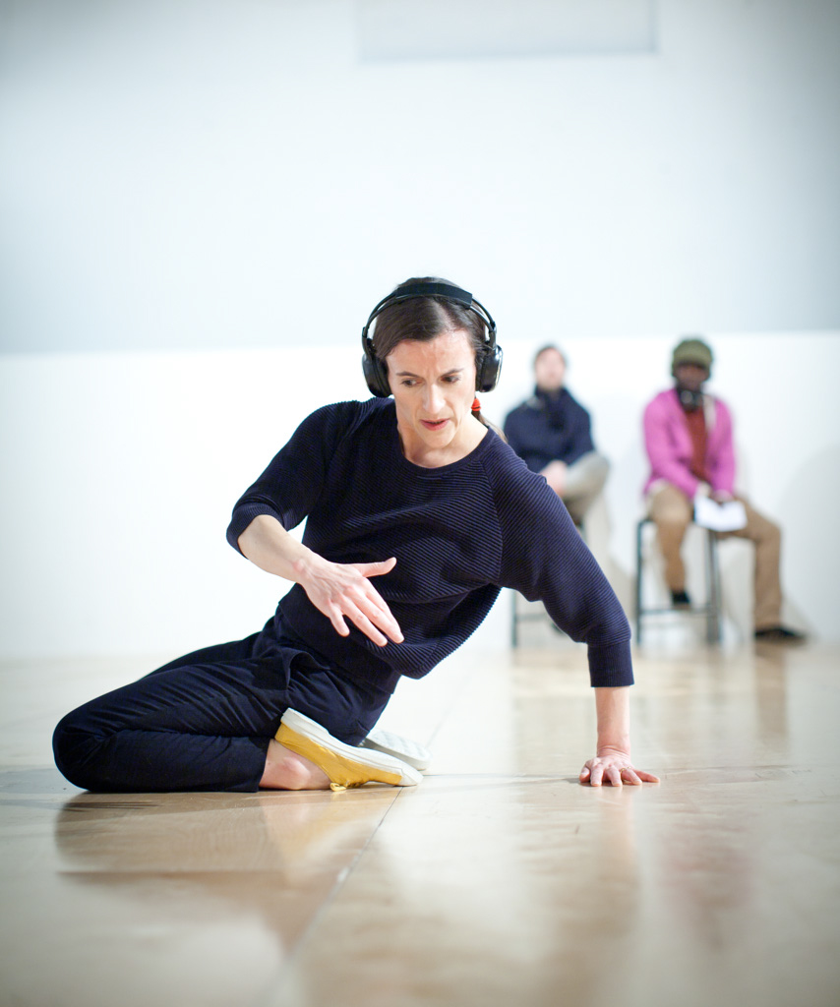

Dancer/Choreographer: Dr Rachel Krische, Leeds School of Arts
Photo Credits:
Photographer: Pari Naderi

